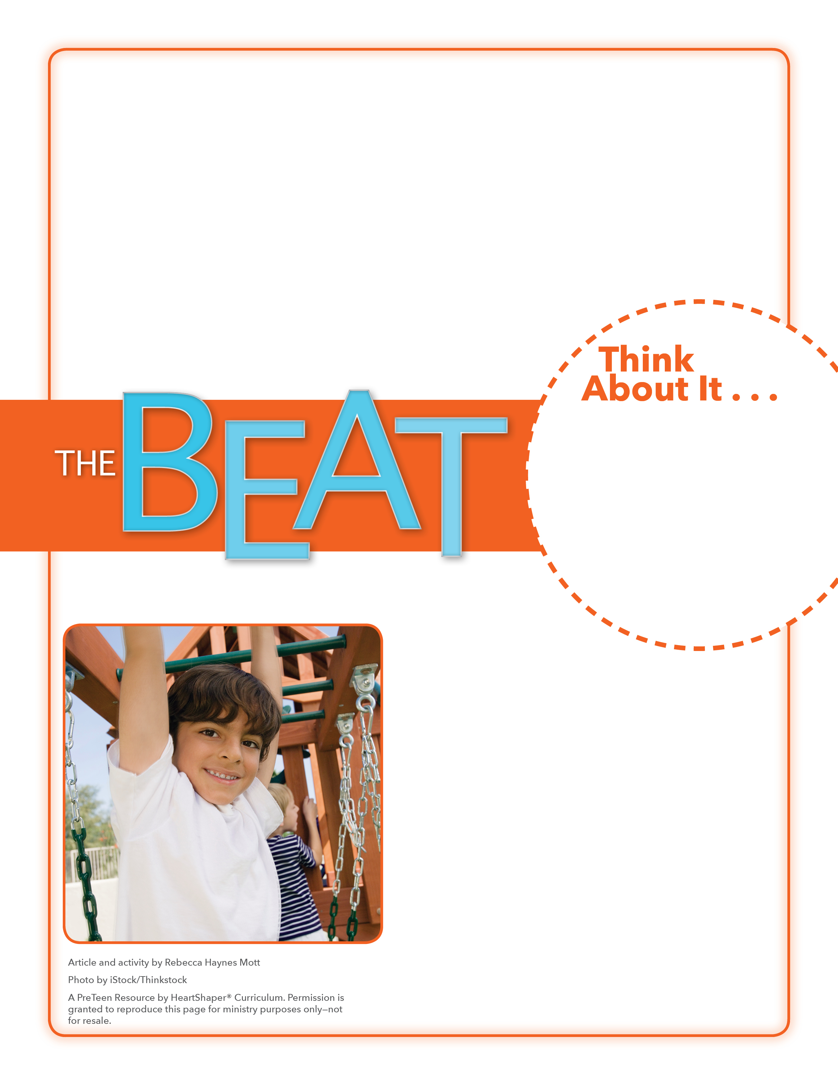
• What does it mean to worry about something?
• What do preteens worry about a lot?

What Do You Worry About?
Will you trust God to meet your physical needs?
Give each student two slips of paper. Ask students to write one thing they worry about on each slip of paper. Tell them to only write things that they don’t mind others hearing. Collect the papers. Choose a couple volunteers to go to the board. As you read aloud what’s written on each slip of paper, the volunteers can write what you say on the board. When finished, ask preteens to comment on the things written on the board. SAY: Let’s dig into God’s Word and see what it says about worry.

November 13, 2016
Lesson 11
Hurricane Matthew had a lot of people worried when it headed toward the United States last month. More than 1.5 million people in Florida were told to leave their homes. Schools were shut down so families could get ready to leave. Government officials and news reporters warned that if people didn’t get out, there was a good chance they would die in the huge storm. And people who weren’t anywhere near the hurricane’s path worried about their friends who were. Keenan, who is 9 years old, said: “I will never forget that storm for the rest of my life. I was worried because I knew there was always a possibility that it would come and hit us.” Keenan’s family—who lives in Jacksonville, Florida—left their home and went to Alabama. Hurricane Matthew caused more than $10 billion in damage, and many people were hurt. But fortunately, when Keenan and his family returned home after the storm had passed, Keenan found that his house had not been damaged.

