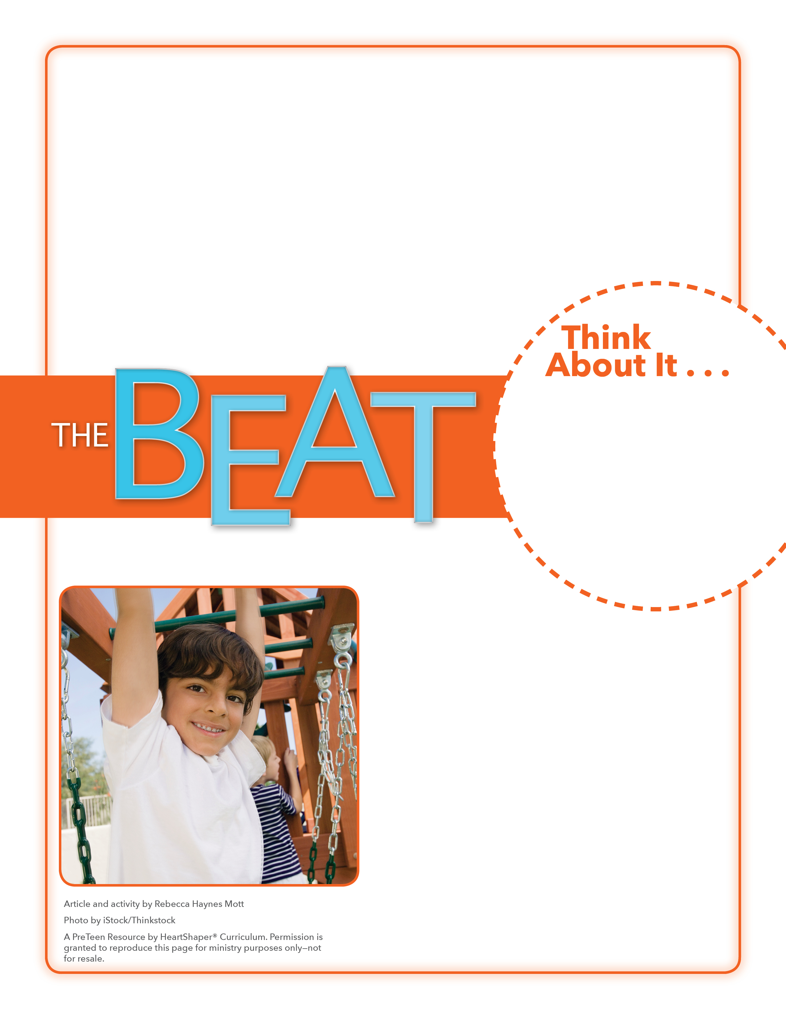
• How did Ms. Wesley demonstrate boldness in the movie?
• What does it mean to show boldness?

Boldness Pyramid
Will you choose to stand up for God with boldness?
Draw a large pyramid on the board and divide it horizontally into three sections. Label the top section “Some,” the middle section “More,” and the bottom section “A lot.” Ask students to think of situations that could require boldness and decide which section of the pyramid their situations would fit in. Let students write their ideas in the pyramid. SAY: Let’s dig into God’s Word and see how some followers of Jesus showed boldness.

October 9, 2016
Lesson 6
In the movie God’s Not Dead 2, the main character is bold in her faith. Other characters in the movie face situations in which they have to decide how bold they will be in stepping out in faith. For instance, when Brook’s brother dies, she asks her favorite history teacher, Grace Wesley, how she deals with hard things. Without hesitation, Ms. Wesley gives Brooke a one-word answer: “Jesus.” Later, when asked in class about Jesus’ place among other well-known leaders, Ms. Wesley boldly shares Scripture showing Jesus’ place. Big trouble for the teacher arises, however, when other students take offense at discussing Jesus in class. Suddenly Ms. Wesley is threatened with losing her job and teaching career. Once again, she has to decide how bold she will be in speaking out for her faith—and how faithful she will be in trusting God with the results.

