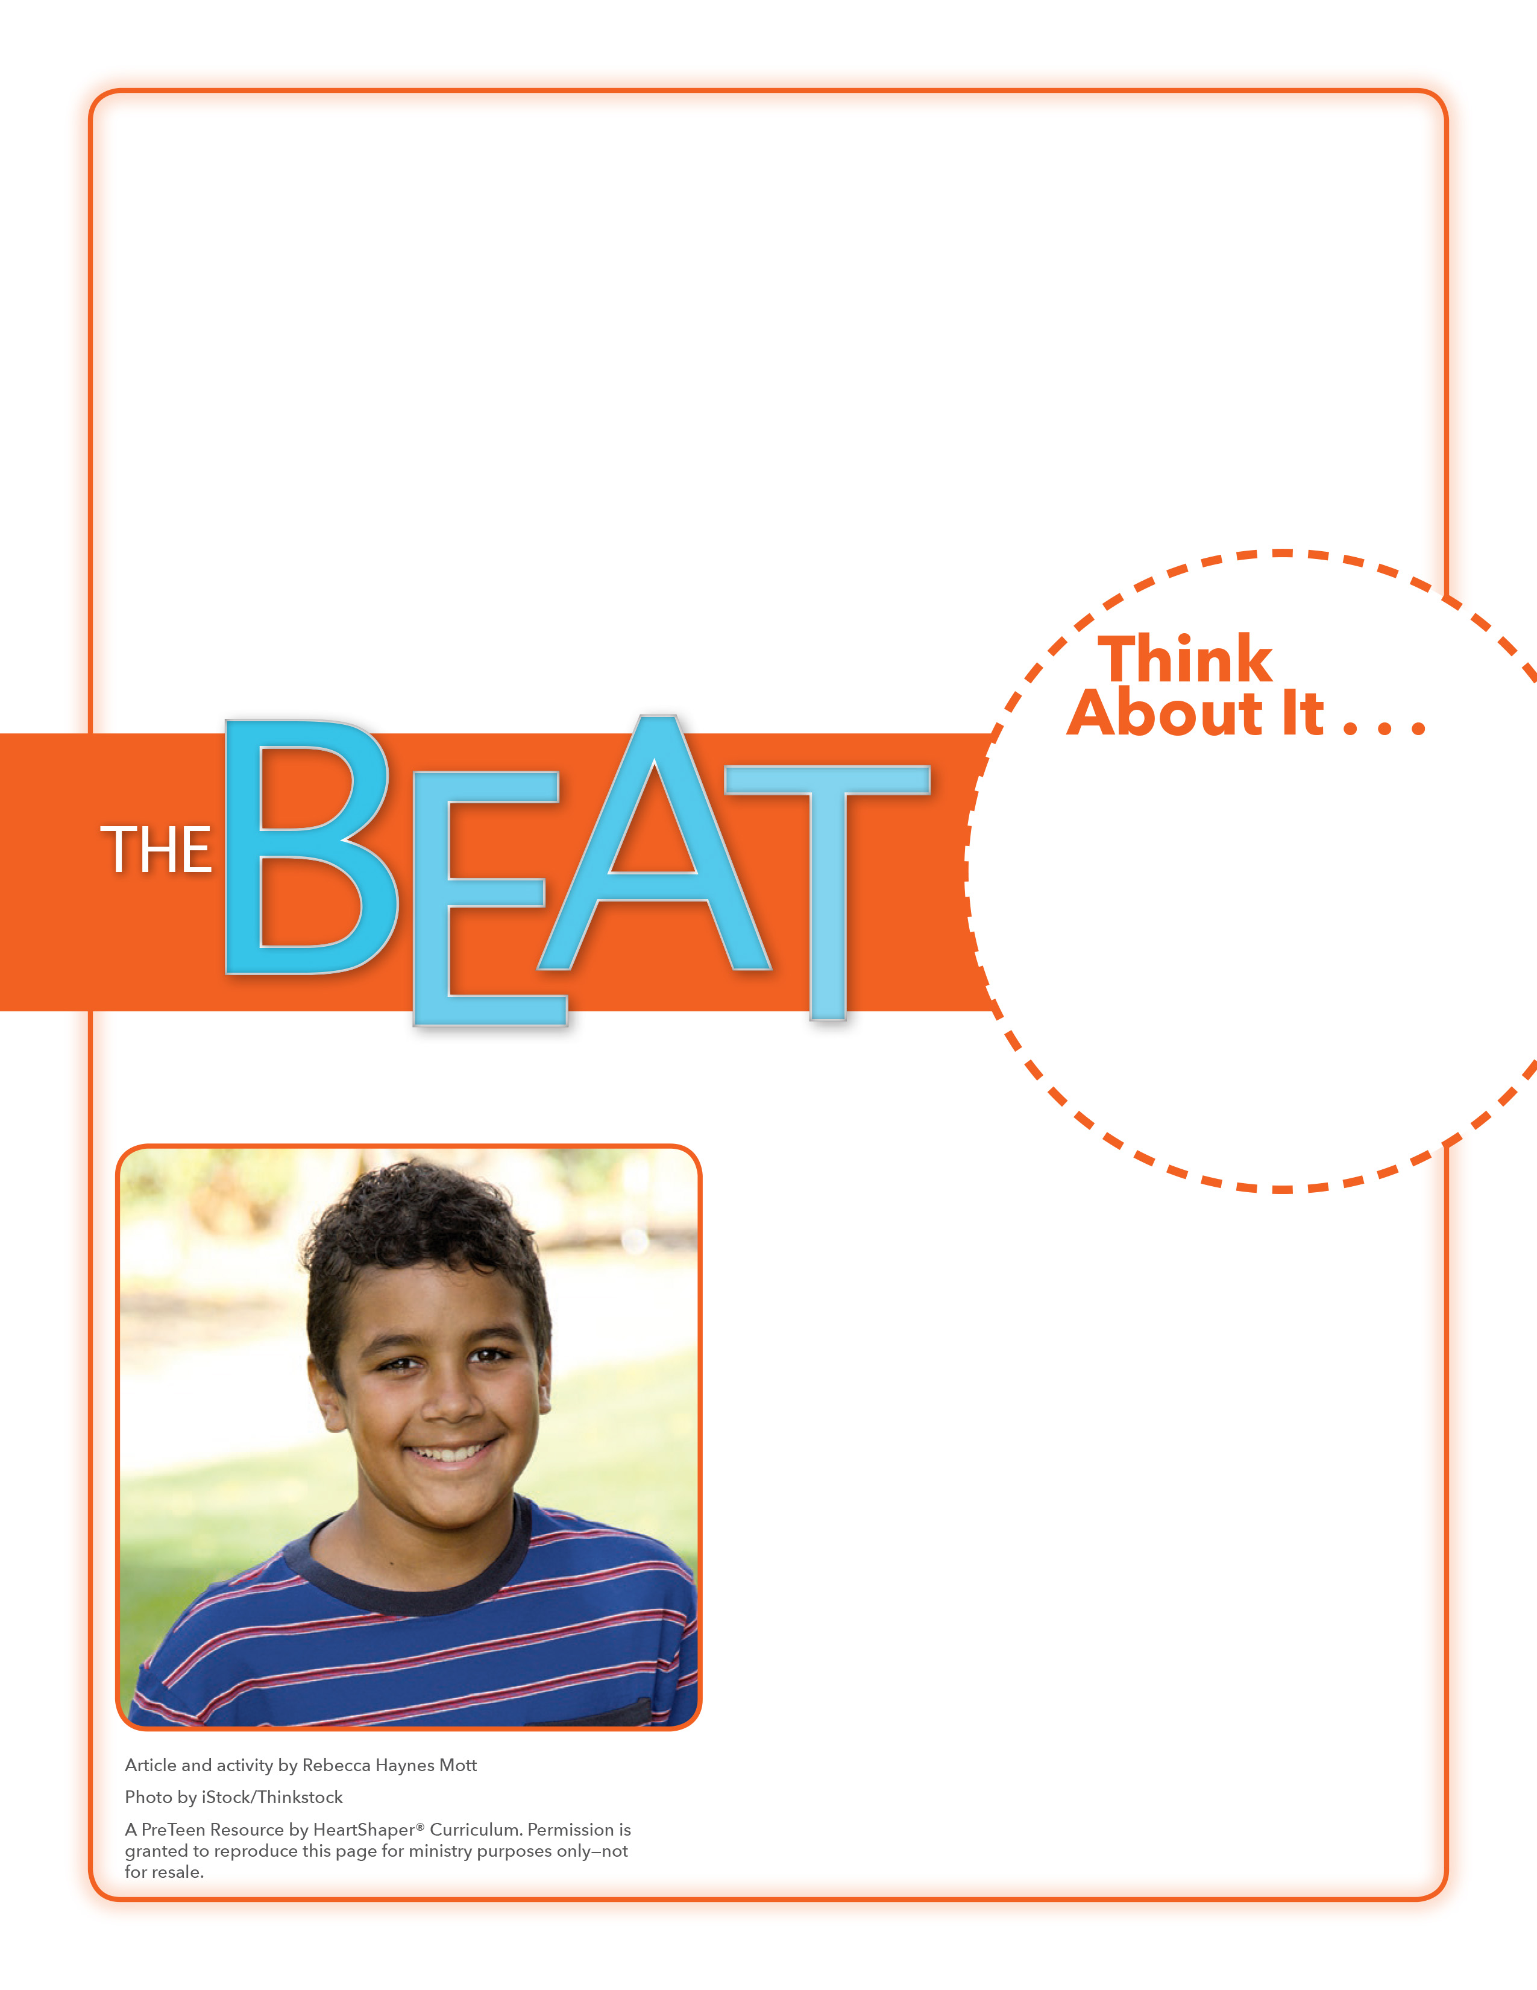
• What does it mean to show humility?
• In what ways did Ms. Hayes show humility?

Draw It, Write It
How will you plan to show humility?
Give each preteen two sheets of paper. They should label one paper “Mr. Arrogant” or “Miss Arrogant” and the other paper “Mr. Humble” or “Miss Humble.” Invite students to draw stick figures of preteens on each paper. Tell preteens to draw speech balloons and thought bubbles coming from each character. Within the balloons and bubbles for Mr. or Miss Arrogant, they should write things that an arrogant person would say and think. Within the balloons and bubbles for Mr. or Miss Humble, they should write things that a humble person would say and think. When everyone is done, let volunteers share what they wrote. SAY: Let’s dig into God’s Word and see what Jesus teaches about showing humility.

May 8, 2016
Lesson 10
On April 28, Jahana Hayes got the surprise of her life. On CBS This Morning, the teacher from Connecticut was named the 2016 National Teacher of the Year. Her whole school cheered for her as they watched the show. Suddenly Ms. Hayes was a celebrity, being interviewed on TV programs and visiting the White House to be recognized by President Obama. But Ms. Hayes wasn’t bragging about herself. One of her strengths is helping students understand that she’s no different than they are and that they too can one day succeed in life. For the next year, Ms. Hayes will travel around the country, sharing that message and her expertise with teachers. Though it’s nice to have won the award, Ms. Hayes is most excited for the opportunity to tell others about all the things she has learned.

